Lab: Reflected XSS into HTML context with nothing encoded
Prepared by: Nihar Mane

INDEX
Report Metadata……………………………………………………………………………………………..2
Executive Summary…………………………………………………………………………………………2
Scope…………………………………………………………………………………………………………2
Methodology………………………………………………………………………………………………….2
Step-by-Step Execution……………………………………………………………………………………..2
Impact Assessment………………………………………………………………………………………….3
Remediation………………………………………………………………………………………………….4
Conclusion……………………………………………………………………………………………………4
References……………………………………………………………………………………………………4

Report Metadata

Lab: Reflected XSS into HTML context with nothing encoded — PortSwigger Web Security Academy (Apprentice). Target: blog search feature (/?search=). Tools: browser address bar. Tester: Nihar Mane. Date: August 27, 2026. Status: Solved — alert(1) executed, lab banner reads “Solved” (Figure 2).

Executive Summary

This lab demonstrates a reflected XSS vulnerability where the blog’s search results page echoes the search term directly into the page’s HTML without any encoding. Submitting <script>alert(1)</script> as the search term causes the script to execute immediately in the response.

Scope

In scope: the search parameter on the blog search page of the assigned PortSwigger lab instance. Out of scope: all other endpoints and any production system

Methodology

Submit a script payload as the search term and observe whether it executes immediately in the resulting page.

Step-by-Step Execution

Step 1: Copy and paste the following into the search box: <script>alert(1)</script> and then
Click "Search".

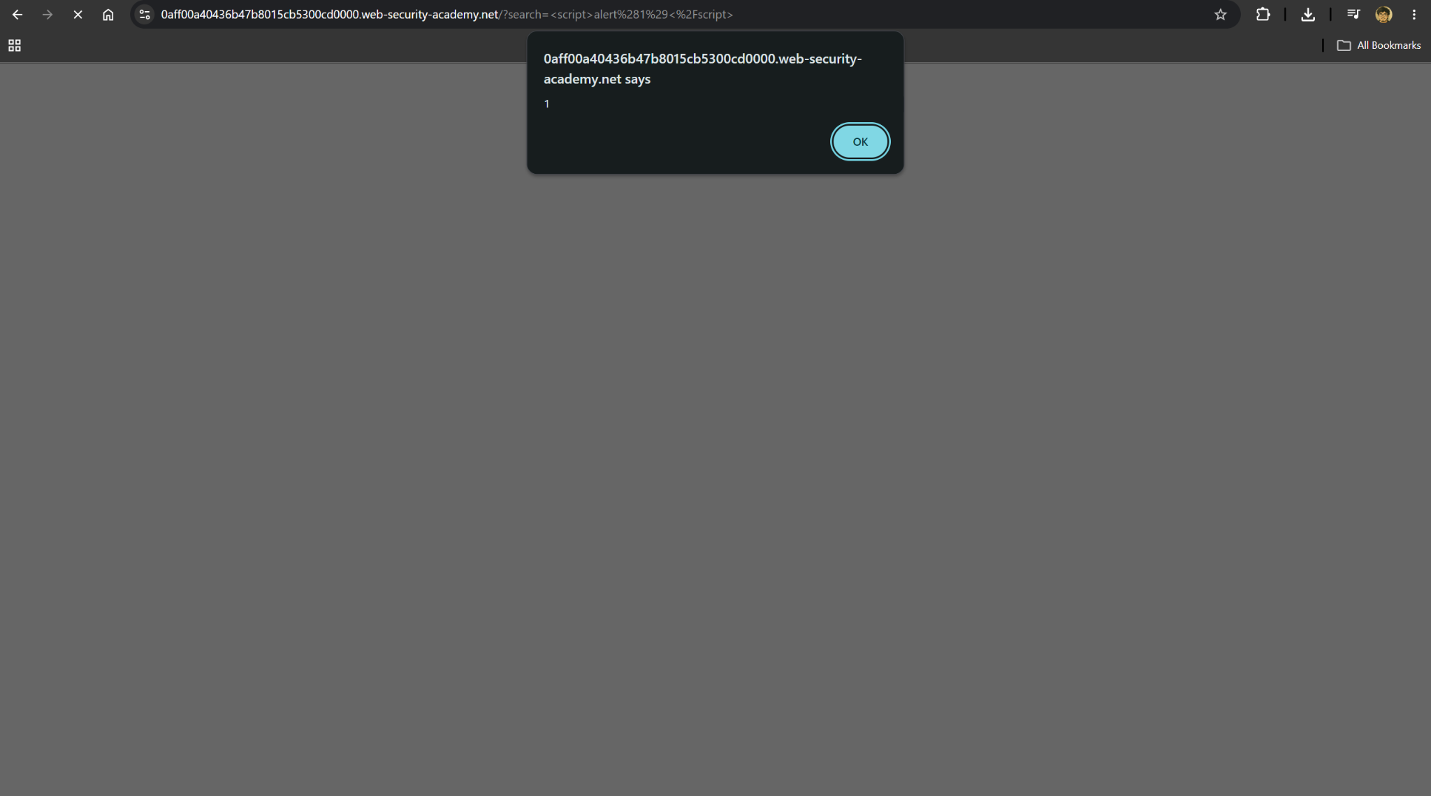
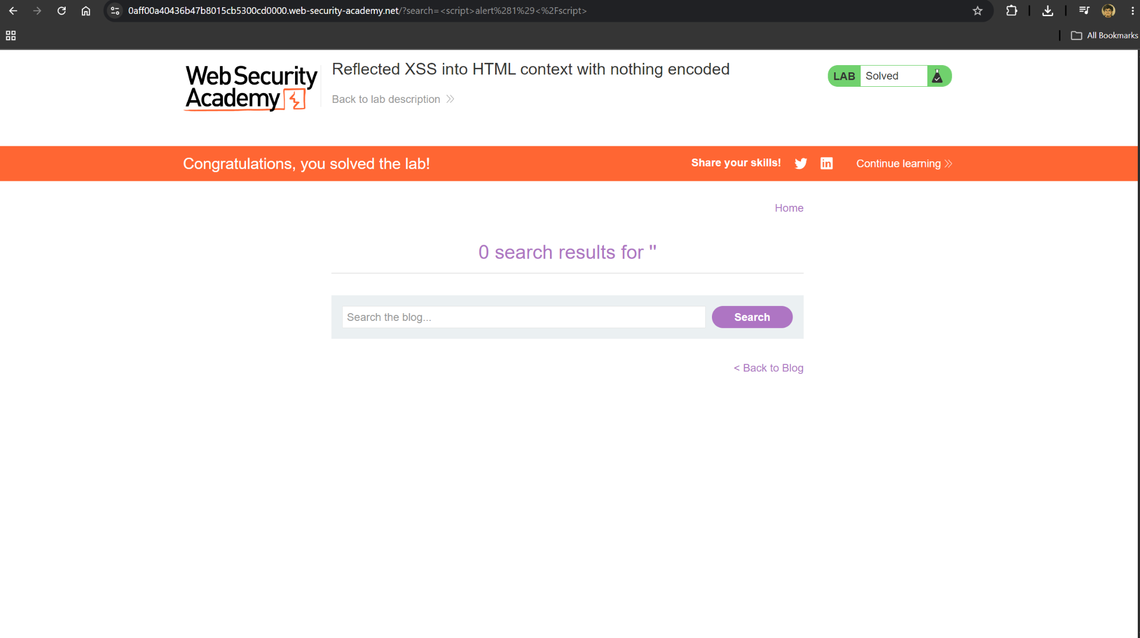

Impact Assessment

• Immediate execution: the payload runs as soon as the crafted request is submitted or a victim clicks a malicious link.
• Session hijacking: an attacker can steal cookies or perform actions as the victim once the script executes.
• Low complexity: no encoding bypass or special tooling is needed, only an unescaped script tag.

Remediation

• HTML-encode the search term (and all reflected user input) before writing it into the response.
• Validate and sanitize input on arrival, rejecting or stripping script tags and event handlers.
• Apply a Content Security Policy to restrict inline script execution as defence in depth.

Conclusion

A single unencoded reflection of the search term was enough to achieve reflected XSS, executing arbitrary JavaScript in the victim’s browser. As with the earlier XSS labs, the fix is the same: encode output and validate input so user-supplied data can never be interpreted as executable code.

References
- LAB https://portswigger.net/web-security/cross-site-scripting/reflected/lab-html-context-nothing-encoded

